TEAMs links:

Conference Theme: CCST Opening, Plenary & CCST Session A

https://teams.microsoft.com/meet/364518884819926?p=dHiwntPSaudLmXHofS

Conference Theme: CCST Session B

https://teams.microsoft.com/meet/396861096023932?p=SzPrXnwBGpOkAfbFjP

Conference Theme: CCST Session C

https://teams.microsoft.com/meet/385287735860756?p=SvBZshOC6f59P5rIQq

July 25/Day 1
(China Standard Time/UTC+8)
China Time
8:30-8:40 | Opening Ceremony  (Chair: Professor Zhongde Dai)
8:40-8:50 | Awarding  (Chair: Professor Hui Zhou)
8:50-9:30 | Plenary 1: Professor Sandra Boetcher  Techno-Energy Assessment of Hybrid Pressure Swing Adsorption and Cryogenic Direct Air Capture  (Chair: Professor Shouliang Yi)
9:30-10:10 | Plenary 2: Professor Lidong Wang  (Chair: Professor Zhongde Dai)
10:10-10:20 | Breaks
10:20-12:00 | Integrated carbon capture and utilization (ICCU)  Session chairs: Lei Liu | CO₂ utilization and storage Session chairs: Zhao Sun | Direct air capture (DAC)  Session chairs: Hui Zhou
12:00-14:00 | Lunch
14:00-14:40 | Plenary 3: Professor Mengxiang Fang  Solvent development for CO₂ chemical absorption process  (Chair: Professor Shouliang Yi)
14:40-15:20 | Plenary 4 Professor Mingyue Ding  Directional Catalytic Conversion Of COx Molecules  (Chair: Professor Haiping Yang)
15:20-15:30 | Breaks
15:30-17:30 | Carbon capture with liquid absorbents  Session chairs: Hui Jin | Carbon capture with membranes  Session chairs: Shouliang Yi  Co-chairs: Wai Fen Yong | Carbon capture with solid sorbents  Session chairs: Cong Luo
17:30-18:30 | Dinner
18:30-19:10 | Plenary 5: Prof. Vivek Polshettiwar  Light, hot electrons and CO₂ conversion  (Chair: Professor Chunfei Wu)
19:10-19:50 | Plenary 6: Prof Yongchun Zhao  Direct Photocatalytic Reduction of CO₂ with SO₂ Impurity by Pt Modified TiO2  (Chair: Professor Shuangjun Li)

July 26/Day 2
(China Standard Time/UTC+8)
China Time
8:30-9:10 | Plenary 7: Professor Xian Zhang  (Chair: Professor Zhongde Dai)
9:10-9:50 | Plenary 8: Professor Zhongyi Jiang  Organic molecular sieve membranes for carbon capture  (Chair: Professor Shouliang Yi)
9:50-10:00 | Break
10:00-12:00 | Process integration, intensification, modelling, and artificial intelligence in carbon capture  Session chairs: Yongqing Xu | Carbon Neutral for Construction Materials (CCCM)  Session chairs: Xin Xiao | Techno-economic analysis, life-cycle analysis, and demonstration of carbon capture technologies  Session chairs: Xuezhong He
12:00-14:00 | Lunch
14:00-14:40 | Plenary 9: Prof Evgeny Rebrov  Enhancing CO₂ decomposition in DBD reactors: From plasma physics to reactor design  (Chair: Professor Shaojun Xu)
14:40-15:20 | Plenary 10: Prof. Dagang Yu  CO₂ Utilization in Organic Synthesis  (Chair: Professor Zhongde Dai)
15:20-15:30 | Break
15:30-17:50 | Biomass carbon removal and storage (BiCRS)  Session chairs: Dr Chong Yang Chuah | CCUS demonstration  Session chairs: Dingding Yao | Oxyfuel combustion and chemical looping  Session chairs: Li Pengfei
17:50-18:00 | Break
18:00-18:40 | Plenary 11: Dr Paul Iacomi  Surface Measurement System, Realistic screening of materials for carbon capture at the lab scale: cycling, water, sour gas, kinetics and more  (Chair: Professor Chunfei)
18:40-19:00 | Closing Ceremony (Chair: Professor Chunfei Wu)

July 25/Day 1: Parallel Session A (China Standard Time/UTC+8)
Topic: Integrated carbon capture and utilization (ICCU)
China Time |  | Speaker | Title
10:20-10:40 | KA1 | Hongman Sun (China University of Petroleum (East China)) | Integrated CO₂ capture and utilisation: a promising step contributing to carbon neutrality
10:40-11:00 | KA2 | Liang Zeng (Tianjin University) | Calcium Looping Process Development for Integrated Carbon Capture and Utilization
11:00-11:15 | OA1 | Yujie Gan (Central South University) | Achieving High CO Yield via Reverse Boudouard Reaction over Graphite-Fe Catalysts for Hydrogen-Free Integrated Carbon Capture and Utilization
11:15-11:30 | OA2 | Fangshu He (Huazhong University of Science and Technology) | Self-Regenerating Ni/Perovskite-CaO Composites for Long-Term Integrated CO₂ Capture and Dry Methane Reforming
11:30-11:45 | OA3 | Chengang Wang (Huazhong Agricultural University) | Enhanced integrated CO₂ capture and methanation on core–shell dual-functional materials via synergistic physical confinement and alkali metal anchoring
11:45-12:00 | OA4 | Ziqi Zhou (China university of petroleum (East China)) | From Symmetric to Asymmetric Oxygen Vacancies: Unlocking Efficient Ethylene Glycol Oxidation over Pt/TiO₂
Topic: Carbon capture with liquid absorbents
15:30-15:50 | KA3 | Wufeng Jiang (Yangtze University) | Low-Energy Phase-Change Solvents for CO₂ Capture from Natural Gas and Industrial Emissions: From Solvent Design to Molecular Mechanisms
15:50-16:10 | KA4 | Li Sheng (Beijing Institute of Technology) | Low temperature CO₂ desorption enhanced by mutual extraction effect
16:10-16:30 | KA5 | Tohid Borhani (University of Wolverhampton) | How to modify CO₂ Absorption-Desorption system
16:30-16:45 | OA5 | Yalun Zhao (University of Surrey) | Dynamic CO₂ Absorption Modeling in KOH Solution: Single-Pass Gas Flow and Closed-Loop Gas Recirculation
16:45-17:00 | OA6 | Zheng Qiang (Xi'an Jiaotong University) | Development and systematic analysis of non-aqueous superbase-amine-based deep eutectic solvents for efficient CO₂ capture
17:00-17:15 | OA7 | Chujian Lu (University of Science and Technology of China) | Efficient Separation of Methane from Nitrogen by MEL Zeolite for Low-Concentration Coal Mine Methane Upgrading
17:15-17:30 | OA8 | Junhan Lu (Queens's University Belfast) | Graphite–Ni synergy unlocks a hydrogen-free pathway for carbon based integrated CO₂ capture and utilisation (ICCU)

July 25/Day 1: Parallel Session B (China Standard Time/UTC+8)
Topic: CO₂ utilization and storage
China Time |  | Speaker | Title
10:20-10:40 | KB1 | Honglei Zhang (The University of Nottingham Ningbo China) | Enhanced CO₂ photo/electro conversion to value-added products
10:40-11:00 | KB2 | Yingju Yang（Huazhong University of Science and Technology） | Heterostructure Accelerates C–C Coupling Kinetics for Electrocatalytic CO₂-to-C₂H₄ Reduction
11:00-11:15 | OB1 | Hongyuan Ma (Shandong University) | Atomic-level Anchoring Strategy for Constructing Highly Stable NiGe@S-1 Catalysts for Greenhouse Gas Valorization
11:15-11:30 | OB2 | Zijian Zhou (Huazhong University of Science and Technology) | Synergistic Ternary Layered Double Hydroxides with Electronic Modulation for Enhanced Carbon Dioxide Photoreduction
11:30-11:45 | OB3 | Liuping Chen (Huazhong University of Science and Technology) | Interpretable Machine Learning-Based Multi-Objective Optimization of ABO₃-Type Perovskite Catalysts for Dry Reforming of Methane
11:45-12:00 | OB4 | Jing Yang (Jiangsu University) | Coordination Engineering of Iron Single Atoms for Efficient CO₂ Reduction in SO₂-Rich Flue Gas
Topic: Carbon capture with membranes
15:30-15:50 | KB3 | Wai Fen YONG (Xiamen University Malaysia) | Membrane Technology for a Low-Carbon Future: Advancing Green CO₂ Capture
15:50-16:10 | KB4 | Xuezhong He (Guangdong Technion-Israel Institute of Technology) | PVAm-based Membranes for Carbon Capture from Flue Gases: Status, Challenges and Perspectives
16:10-16:25 | OB5 | Junfeng Zheng (Sichuan University) | High performance CO₂ separation membranes based on block copolymer micro-structure rearrangement
16:25-16:40 | OB6 | Hao Yi Peng (Xiamen University Malaysia) | Bridging Polymer and MOF in Membranes: Amine Cross-linking for Sub-nanometer Control and Enhanced Stability
16:40-16:55 | OB7 | REZA GODARY (Xiamen University Malaysia) | Bimodal porous hollow silica sphere modified mixed matrix membranes for high-performance CO₂ separation
16:55-17:10 | OB8 | Hui Shen LAU (Xiamen University Malaysia) | Tandem green-engineered long-stable polymer-nano fused membranes for efficient carbon capture
17:10-17:25 | OB9 | Zhe Lu ( Ganjiang Innovation Academy, Chinese Academy of Sciences) | Tailored Pore Engineering for Efficient CH₄/N₂ Separation via Synergistic Etching on Coconut Shell Activated Carbon

July 25/Day 1: Parallel Session C (China Standard Time/UTC+8)
Topic: Direct air capture (DAC)
China Time |  | Speaker | Title
10:20-10:40 | KC1 | Ziyi Li (University of Science and Technology Beijing) | Thermal-Swing-Free VPSA Enabled by a Monolithic Solid Amine for Energy-Efficient CO₂ Capture from Hydrocarbon Streams
10:40-10:55 | OC1 | GuangLi He (Changsha University of Science & Technology) | Microwave-assisted Desorption of CO₂ and H₂O from Amine-functionalized Adsorbents for Direct Air Capture
10:55-11:10 | OC2 | Duan Wenxuan (Shanghai Jiao Tong University) | Polyethylene Glycol-Assisted Honeycomb-Structured Supported Amine Adsorbents for Direct Air Capture: Green Preparation, Performance Characterization and Process Optimization
11:10-11:25 | OC3 | Ganzhuo Zhen (Shanghai Jiao Tong University) | Efficient and Stable Direct Air Capture in Alumina-Based Solid Amine Adsorbents via Magnesium Doping
11:25-11:40 | OC4 | Hongyuan Jiang (Shandong University) | Dynamic Cation Gating in Na-MOR Zeolites: Unveiling the CO₂-Induced Migration Mechanism for Enhanced Direct Air Capture of CO₂
Topic: Carbon capture with solid sorbents
15:30-15:50 | KC2 | Lei Liu (Changsha University of Science & Technology) | Effect of Moisture on CO₂ Adsorption by Novel Heterocyclic Amine-functionalized Adsorbents and N-doped Biocarbon Adsorbents
15:50-16:10 | KC3 | Yongqiang Wang (University of Cambridge) | Distinct roles of carbonates inside and outside nanopores for direct air capture
16:10-16:30 | KC4 | Yuanting Qiao (Swansea University) | Techno-economic analysis for Decarbonisation Technologies
16:30-16:50 | KC5 | Cheng Shen (Jiangsu University of Science and Technology) | Trace NaBr-assisted Al₂O₃ doping for enhanced cyclic carbonation of CaO and its anti-sintering mechanism
16:50-17:10 | KC6 | Siming You (University of Glasgow) | Environmental impact assessment of waste management and application of machine learning methods
17:10-17:25 | OC5 | Nanjuan Duan (Central South University) | Structural modulation of ZSM-5 derived Li₄SiO₄ sorbents for enhanced high-temperature CO₂ capture
17:25-17:40 | OC6 | Godknows Dziva (Institute of Process Engineering, CAS) | Design and experimental testing of novel moving bed sorption-enhanced biomass gasifiers

July 26/Day 2: Parallel Session A (China Standard Time/UTC+8)
Topic: Process integration, intensification, modelling, and artificial intelligence in carbon capture
China Time |  | Speaker | Title
10:00-10:20 | KA6 | Lu Yao (Sichuan University) | Coke-Resistant Ni Catalysts for Efficient CO₂-CH₄ Reforming to Syngas
10:20-10:35 | OA9 | Han Han (University of Shanghai for Science and Technology) | Geothermal energy-driven carbon capture from associated gas for CO₂-enhanced oil recovery
10:35-10:50 | OA10 | Yuxuan Zhang (Zhejiang University) | Investigation of the Nucleation Mechanism of Amine Aerosols in Alkanolamine-Based Carbon Capture Processes
10:50-11:05 | OA11 | Yang Wu (Zhejiang University) | Numerical study of a two-stage trough-type liquid distributor for amine emission control in CO₂ absorbers columns
11:05-11:20 | OA12 | Yang Wang (Shanghai Jiao Tong University) | A Process-aware Scheduling strategy upon Forecast-Based Rolling Optimization for Renewable-Powered Adsorption Direct Air Capture Systems
Topic: Biomass carbon removal and storage (BiCRS)
15:30-15:50 | KA7 | Daxin Liang (Jiamusi University) | Construction of Green and Efficient Lithium Extraction System Based on Biomass Composites: Experimental Innovation and ML-Aided Design
15:50-16:10 | KA8 | Dengrong Sun (Sichuan University) | Microenvironment Engineering in Metal-Organic Framework (MOFs) for Electrocatalytic Oxygen Evolution Reaction
16:10-16:30 | KA9 | Cui Wang (Chang’an University) | Pore structure evolution and kinetics of biomass supercritical water gasification for negative carbon utilization
16:30-16:45 | OA13 | Tingwei Wang (Central South University) | Deoxygenation-sorption-enhanced biomass gasification for green hydrogen energy
16:45-17:00 | OA14 | Pablo Comendador (University of the Basque Country) | Thermodynamic analysis of HDPE pyrolysis and in line sorption enhanced steam reforming with CO₂ utilization
17:00-17:15 | OA15 | Wenchao Mao (Huazhong University of Science and Technology) | Study on combustion characteristics affected by the interaction from coal/biomass co-firing under O₂/CO₂/H₂O conditions
17:15-17:30 | OA16 | Ke Li (Central South University) | Thermodynamic Analysis of Biogas Reforming for Hydrogen Production: A Comparative Investigation
17:30-17:45 | OA17 | Qianjun Gao (Changsha University of Science and Technology) | influence of pore structure and nitrogen-containing functional groups on the competitive adsorption of high-pressure CO₂/H₂ by biochar

July 26/Day 2: Parallel Session B (China Standard Time/UTC+8)
Topic: Carbon Neutral for Construction Materials (CCCM)
China Time |  | Speaker | Title
10:00-10:20 | KB5 | Zhao Sun (Central South University) | Carbon nanotube synthesis from CO₂
10:20-10:35 | OB10 | YANG BO (Kangwon National University) | Application of Wet Carbon Conversion in Alkali-Activated Slag for Enhancing Microstructure and Mechanical Properties
10:35-10:50 | OB11 | SUN FENG (Kangwon National University) | Effect of sodium carbonate (Na₂CO₃) on the engineering performance of a three-component mixture of cement, limestone, and slag
10:50-11:05 | OB12 | WANG KANGJIA (Kangwon National University) | Improvement in the Properties of Waste Oyster Shell Powder–Cement Composite Systems by Carbonation Treatment
11:05-11:20 | OB13 | ZHU RUIXUAN (Kangwon National University) | Sustainable Design Optimization of Metakaolin-Modified Concrete Based on CO₂ Emissions and Cost
11:20-11:35 | OB14 | MENG LIYI (Kangwon National University) | Low-Carbon Ultra-High-Strength Concrete: Synergistic Benefits of Belite-Rich Portland Cement on Shrinkage Control and Carbon Efficiency
Topic: CCUS demonstration
15:30-15:50 | KB6 | Grazia Leonzio (University of Cagliari) | Carbon negative flowstone: a scalable pathway for atmospheric CO₂ capture and mineralization
15:50-16:10 | KB7 | Medhat A. Nemitallah (King Fahd University of Petroleum and Minerals) | Powering the Future: Solutions Towards Efficient Low-Carbon ICEs
16:10-16:30 | KB8 | Min Wu (Aarhus University) | Transforming CO₂ into building materials: How close are we to this gigaton-scale decarbonation strategy
16:30-16:50 | KB9 | Mengyang Fan (Sichuan University) | Interfacial Microenvironment Design for Carbon-Efficient CO₂ Electroconversion
16:50-17:05 | OB15 | Tang Jianbo (Shandong University) | Adsorption-based compressed CO₂ enervy storage system：A comprehensive analysis
17:05-17:20 | OB16 | Jinbiao Luo (University of Science and Technology of China) | The role of heavy reflux in pressure swing adsorption for industrial carbon capture
17:20-17:35 | OB17 | Hao Yuan (University of Science and Technology of China) | Research on CO₂ Separation from Flue Gas Based on a Six Column VSA Process
17:35-17:50 | OB18 | Yi-Sheng Wang (Kangwon National University) | The influence mechanism of quartz powder fineness and content on the improvement of carbonization curing efficiency

July 26/Day 2: Parallel Session C (China Standard Time/UTC+8)
Topic: Techno-economic analysis, life-cycle analysis, and demonstration of carbon capture technologies
China Time |  | Speaker | Title
10:00-10:20 | KC7 | Muhammad Saddam Hussain (Tsinghua University) | Techno-economic analysis and life cycle assessment of integrated carbon capture and methanation using Ni/MgO/Al₂O₃ dual functional material
10:20-10:40 | KC8 | Pengfei Li (Huazhong University of Science and Technology) | Oxy-Fuel Combustion Carbon Capture: Recent Advances and Emerging Trends
10:40-10:55 | OC7 | Hong Quan (Tianjin University) | Unraveling the Mechanism of Microwave-Enhanced CO₂ Desorption: From Hot-Spot Modeling to Techno-Economic Analysis
10:55-11:10 | OC8 | Yangsong Yang (University of Shanghai for Science and Technology) | A Low-Carbon-Emission Combined Cooling, Heating, and Power System Integrated with Heat Pump Technology: Thermodynamic and Thermal Economic Analysis
11:10-11:25 | OC9 | Xinyu Liu (Guangdong University of Technology) | Exploring the Realistic Carbon Removal Potential of Direct Air Capture: A Dynamic Life Cycle Assessment
Topic: Oxyfuel combustion and chemical looping
15:30-15:50 | KC9 | Xiaojia Wang (Southeast University) | Scaling-Up of Solid Fuel Chemical Looping Combustion
15:50-16:10 | KC10 | Bo Jin (Hunan University) | Two-Lever Design Rule for High-Entropy Oxide Oxygen Carriers: Minimize Spin Polarization, Maximize Fe–O–Ni Covalency
16:10-16:25 | OC10 | Natsayi Chiwaye (University of the Witwatersrand) | Identifying Life Cycle Environmental Impacts of Carbon Capture in Coal-Fired Power Plants in South Africa
16:25-16:40 | OC11 | Peng Su (Certral South University) | CeO₂-Induced Interfacial Oxygen Defects Promote CO₂ Activation and Redox Stability in Mn–Fe Spinel Oxygen Carriers
16:40-16:55 | OC12 | Panting Li (Central South University) | Mn/Ni-Regulated LaFeO₃ Perovskite Oxygen Carrier for Efficient Chemical Looping Dry Reforming of Methane
16:55-17:10 | OC13 | Jiqiang Zhou (Changsha University of Science & Technology) | Anti-oxidative degradation of heterocyclic amine-funcitionalized adsorbent

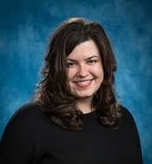
Professor Sandra Boetcher, Embry-Riddle Aeronautical University
Title: Techno-Energy Assessment of Hybrid Pressure Swing Adsorption and Cryogenic Direct Air
Sandra Boetcher is a Professor of Mechanical Engineering at Embry-Riddle Aeronautical University. She also serves as Chair of the Department of Engineering Fundamentals. She received her B.M.E., M.S., and Ph.D. in Mechanical Engineering from the University of Minnesota in 2001, 2003, and 2006, respectively. Prior to her appointment at Embry-Riddle, Professor Boetcher was a founding faculty member in the newly formed Department of Mechanical and Energy Engineering at the University of North Texas and worked for several companies, including Honeywell, 3M, and Donaldson Company. Her recent research interests include developing latent heat thermal energy storage systems using advanced manufacturing, investigating the fundamental behavior of phase-change materials through numerical simulations and experiments, and characterizing the heat transfer performance of supercritical fluids. She is the recipient of the ASME Dedicated Service Award (2023), the ASHRAE E.K. Campbell Award (2025), and the ASME Heat Transfer Memorial Award (2026). She is currently the Editor-in-Chief of Numerical Heat Transfer Part A: Applications, an Associate Editor of Carbon Capture Science and Technology, an Associate Editor of the International Journal of Heat and Fluid Flow, and an Associate Editor for the ASME Journal of Heat and Mass Transfer. She also serves as a U.S. delegate to the Assembly for International Heat Transfer Conferences (AIHTC), is the Past Chair of the ASME Heat Transfer Division, and is a Fellow of ASME.

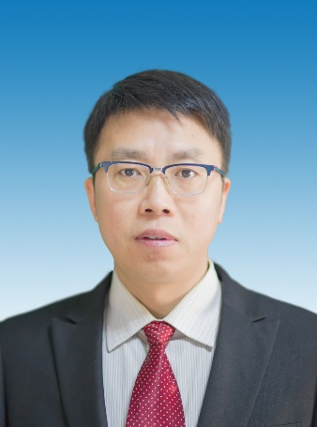
Professor Lidong Wang, North China Electric Power University
Title: TBD
Dr. Wang Lidong is the Dean of the School of Environmental Science and Engineering at North China Electric Power University, Deputy Director of the Key Laboratory of Resource and Environmental Systems Optimization under the Ministry of Education, an expert of the Overall Expert Group for the Key Special Project “Clean and Efficient Utilization of Coal Technology” under the National Key R&D Program of the Ministry of Science and Technology, and Chair of the Carbon Neutrality Information Technology Committee of the International Society for Environmental Information Sciences. He is a recipient of the National Science Fund for Distinguished Young Scholars, and as the team leader, his group was selected among the first batch of “Huang Danian-style” faculty teams in universities of Hebei Province.
Dr. Wang Lidong has long been dedicated to research on pollution reduction and carbon mitigation technologies for coal-fired flue gas, and has actively promoted the development of pollutant emission reduction and carbon capture, utilization and storage (CCUS) technologies in China’s coal power sector. He has published over 220 SCI papers in top-tier journals in the field of environmental engineering. He has led more than 20 research projects, including the National Science and Technology Major Project for Comprehensive Environmental Management of the Beijing-Tianjin-Hebei Region, sub-projects of the National Key R&D Program, and projects funded by the National Natural Science Foundation of China. As a core member, he contributed to the Ministry of Education’s “Action Plan for Carbon Neutrality Science and Technology in Higher Education Institutions” and the Ministry of Ecology and Environment’s “China CCUS Annual Report (2021).” His research achievements have been applied in more than 200 coal-fired power plants and industrial boilers nationwide.

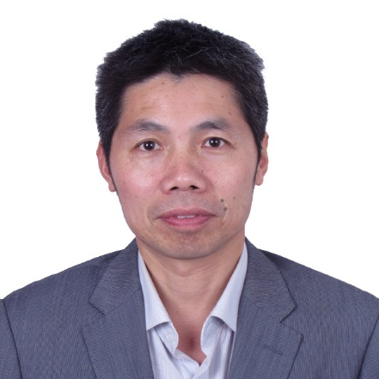
Professor Mengxiang Fang, Zhejiang University
Title: Solvent development for CO₂ chemical absorption process
Prof. Mengxiang Fang, a professor at College of Energy Engineering of Zhejiang University, Director of Qingshanhu Energy Research Center of Zhejiang University. His interest is CO2 chemical absorption including low energy consumption amine based solvents development and management, energy saving process and amine emission control. He has already been responsible to finished more than 40 projects including National Natural Science Foundation Project, National Key Basic Research Project(973), National High Technology Research and Development Project(863), EU cooperation project, China International cooperation projects. He got more than20 patents and presented more than 200 papers in Journal and conference. He got a 2nd award of Science &Technology Progress of State and two 1st award of Science &Technology Progress of Province.

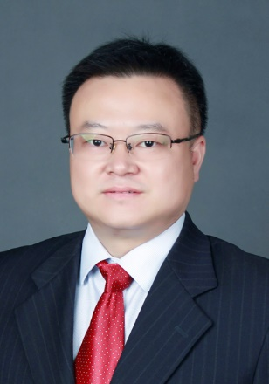
Professor Mingyue Ding, Wuhan University
Title: Directional Catalytic Conversion Of COx Molecules
Mingyue Ding is a Professor at Energy and Chemical Engineering department in Wuhan University Since 2016. He received his B.S. degree in applied chemistry from Wuhan University in 2003, and Ph.D. degree in physical chemistry from Institute of Coal Chemistry, Chinese Academy of Sciences in 2009. His group mainly focus on the conversion of syngas derived from coal or biomass to clean liquid fuels, the catalytic conversion of CO₂ to chemicals. As the first or corresponding author, he has published more than 150 high-level SCI papers in authoritative international energy and catalysis journals such as Science, PNAS, Chem and ACS Catal.. He has received a number of awards, including Changjiang Scholars of the Ministry of Education, Distinguished professor of Chutian Scholars in Hubei Province.

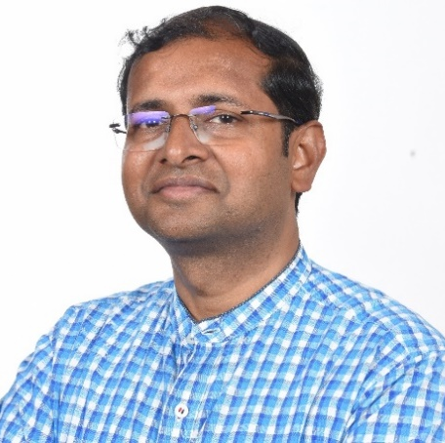
Professor Vivek Polshettiwar, Tata Institute of Fundamental Research (TIFR)
Title: Light, hot electrons and CO₂ conversion
Prof. Vivek Polshettiwar is Professor of Chemistry at Tata Institute of Fundamental Research (TIFR), Mumbai, where his research lies at the interface of nanomaterials and catalysis, with a focus on solar energy harvesting and the conversion of CO₂ into fuels and chemicals. He is the inventor of dendritic fibrous nanosilica (DFNS) and plasmonic Black Gold. His work spans materials chemistry, plasmonics, defect engineering, and strong metal–support interactions, providing design principles for next-generation catalysts to address critical energy and environmental challenges. He has published nearly 150 peer-reviewed articles and holds 17 national and international patents and patent applications. He has over 20000 citations with an h-index of 70.
His work has been recognized with numerous prestigious honors, including the ORISE Research Fellowship (US EPA), the Asian Rising Star Lectureship from Nobel Laureate Prof. Ei-ichi Negishi, the IUPAC CHEMRAWN VII Prize for Green Chemistry, the MRSI and CRSI Medals, and the Falling Walls Award, Germany (Winner in Physical Sciences, 2023). He is a Fellow of the National Academy of Sciences, India (FNASc), the Indian Academy of Sciences (FASc), and the Royal Society of Chemistry (UK). In 2024, he received the Shanti Swarup Bhatnagar Award, one of the India’s highest science honor, conferred by the President of India.

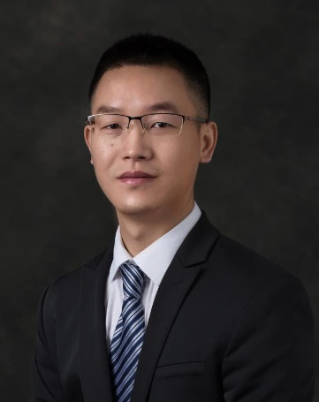
Professor Da-Gang Yu, Sichuan University
Title: CO₂ Utilization in Organic Synthesis
Da-Gang Yu received his BS degree from Sichuan University in 2007 and PhD from Peking University in 2012 (Mentor: Professor Zhang-Jie Shi). He then conducted postdoctoral research as a Humboldtian in Professor Frank Glorius’ group at the University of Muenster. In 2015, he was appointed as Professor in the College of Chemistry of Sichuan University to carry out his independent work, focusing on the CO₂ utilization in organic synthesis. He has published more than 130 corresponding author papers published in Nature, Nat. Catal., and other journals. He received New Era Youth Pioneer Award of China, Chinese Chemical Society-Royal Society of Chemistry Youth Award and Kyoto Rising-Star Lectureship Award. He is also serving as Associate Editors for Chemical Synthesis and Chinese Chemical Letters.

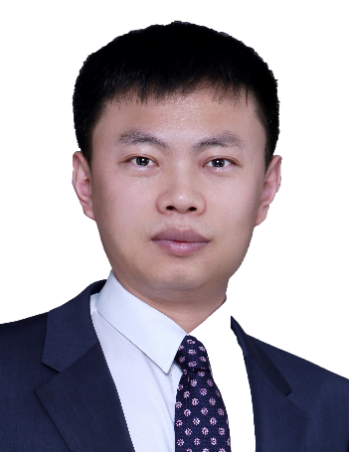
Professor Xian Zhang, National Natural Science Foundation of China，Administrative Center for China's Agenda 21
Title: TBD
Dr. Zhang Xian is the director of the Division of Climate Change in the Administrative Center for China's Agenda 21, the director of the Climate Change Committee of the Chinese Society for Sustainable Development, the Chair of the UNCSTD and the committee member of Youth United Association organized by China's state institution at the central level. He has been selected for the National High-Level Talents Special Support Program and the Ten-Thousand Program for Young Talents, listed among the Top 2% of the World's Top Scientists, and WRIII Coordinating Lead Author of the IPCC AR7 report.
Dr. Zhang Xian has been dedicated to strategic research on climate change and low-carbon technology development. He has also been committed to promoting the development of CCUS technology in China and technology transfer in South-South cooperation. Additionally, Dr. Zhang Xian has served as the state representative in international climate change negotiations and multiple cooperation mechanisms. Moreover, he has conducted extensive cooperation with international organizations and institutions, e.g., the United Nations Development Programme and the International Energy Agency.
Dr. Zhang Xian has published more than 150 papers in prominent journals such as Nature Climate Change, Nature Reviews Clean Technology, and One Earth (major environmental sub-journals of Nature and Cell), as well as journals like Engineering from the Chinese Academy of Engineering. Additionally, he has also published more than 20 books, taken a lead or participated in more than 60 national and provincial/ministerial research projects. He has led the research on "The Roadmap for China's Carbon Neutrality Technology Development" and the report "The Roadmap for China's Carbon Capture, Utilization, and Storage Technologies". He is the first author of the CCUS technologies assessment chapters in China's 3rd and 4th National Climate Change Assessment Report.

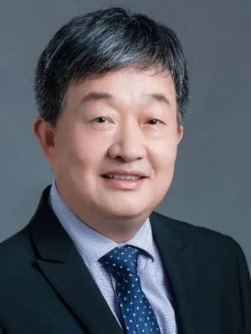
Professor Zhongyi Jiang, Tianjin University
Title: Organic molecular sieve membranes for carbon capture
Zhongyi Jiang is a professor at School of Chemical Engineering and Technology of Tianjin University. He obtained Ph.D. degree in Chemical Engineering from Tianjin University in 1994. He was a visiting scholar of University of Minnesota with Prof. Edward Cussler in 1997 and a visiting scholar in California Institute of Technology with Prof. David Tirrell in 2009.
He is the winner of NSFC Outstanding Young Investigator Award, Cheung Kong Chair Professorship, fellow of the Royal Society of Chemistry (FRSC), fellow of The Chemical Industry and Engineering Society of China (CIESC), fellow of Chinese Chemical Society (CCS). He serves the member of ACS council and chair of ACS Jingjinji International Chapter (2021-).
He is the leader of a scientific innovation team supported by Ministry of Science and Technology of China. He is the Chief Scientist of National Key Research and Development Program. He is the Associate Editor of Advanced Membranes, Research journals, Materials Horizons and the Editorial Board Member of several journals, including Journal of Membrane Science, Macromolecules, Separation and Purification Technology, Green Chemical Engineering, etc.
His research interest primarily focuses on membranes and membrane processes, and enzyme-photo-coupled catalysis. He pioneered the Biomimetic & Bioinspired Membranes and Membrane Processes research direction in membrane field. He proposed the “Organic Molecular Sieve Membrane” concept and “New Three Transfers (electron-proton-molecule transfers) concept. Until now, he has published over 800 SCI papers with total citations over 57000 and h-index 123 (data from Web of Science). He has been consecutively selected on the list of highly cited scientists in the world.


Professor Evgeny Rebrov, University of Warwick
Title: Enhancing CO₂ decomposition in DBD reactors: From plasma physics to reactor design
Professor Rebrov's current research is at the interface between material nano-engineering and catalytic reactor engineering with a strong focus on the application of nonconventional energy sources, such as microwave, radiofrequency fields and UV light, to activate catalysts and to intensify reaction and transport processes. The research is focused on the understanding and controlling of the interaction of physical transport and reaction processes at all relevant time and length scales in the realization and testing of these chemical reactors for a wide range of applications and processes. Professor Rebrov is an Editor of Chemical Engineering Journal.

Professor Yongchun Zhao, Huazhong University of Science and Technology
Title: Direct Photocatalytic Reduction of CO₂ with SO₂ Impurity by Pt Modified TiO₂
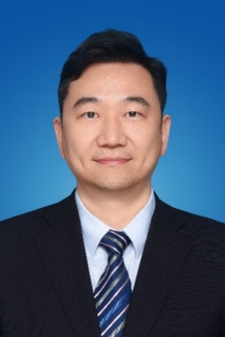
Dr Yongchun Zhao is a Professor of Huazhong University of Science & Technology (HUST). He obtained his Ph.D. from Huazhong University of Science and Technology (HUST) in 2008. From 2007 to 2008, he was study at National Institute of Coal, Spain, as a visiting PhD student. Following postdoctoral work at HUST, he joined the faculty at State Key Laboratory of Coal Combustion (SKLCC) of HUST as an Associate Professor in the end of 2010, as Vice Director of SKLCC since 2014, been promoted to Professor in 2017. He is also the vice dean of School of Energy and Power Engineering, the director of the National Environmental Protection Engineering Technology Center for Trace Elements Pollution Control and Low Carbon Utilization of Coal (TE&CC). His research interests are, at present, focus on CO₂ capture and conversion, CO₂ monitoring, trace element (Hg, As, U…) partition, release, retention, and its potential as a resource, clean and low-carbon energy utilization etc. He is the chief scientist of National Key R&D Programs, Principal Investigator of more than 20 projects supported by National Natural Science Foundation of China (NSFC) and large energy enterprises. He has published more than 150+ peer reviewed international journal papers and given 30+ keynote presentations and invited talks. Based on his achievement, he has elected to National "Ten Thousand Talents Plan" young top talents, received 5 Science and Technology Progress Awards from Hubei and Guangdong Provinces; etc. He has been served as associate editor of Clean Coal Technology, the guest editor of International Journal of Coal Geology, Journal of Fuel Chemistry and Technology, session chair and committee member of many international conferences.

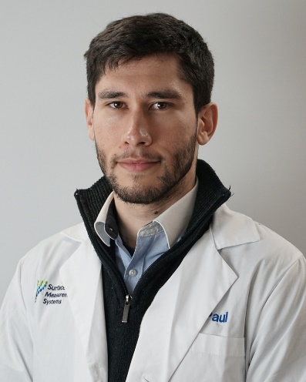
Dr Paul Iacomi, Surface Measurement Systems
Presentation title: Realistic screening of materials for carbon capture at the lab scale: cycling, water, sour gas, kinetics and more
Dr Paul IACOMI is a Research Manager and UKRI Future Leaders Fellow at Surface Measurement Systems (SMS). He holds an EU-funded MSCA PhD in material science from Aix-Marseille University, France. His career has been focused on the advanced characterisation of challenging novel porous materials, like defect-engineered or flexible metal organic frameworks (MOFs), alongside their integration for high-performance applications such as carbon capture, paraffin separation and sensors for satellites. At SMS, his team is leading the development of next generation of sorption methodologies, bringing together a wide range of expertise in sorption techniques and porous material/surface characterisation – including gravimetric and chromatographic (breakthrough) instruments. His research output comprises over 25 peer reviewed publications, 1 patent and 1 book chapter.

Sponsors


Partners



